Shape Coding – A method of explicitly teaching grammar rules

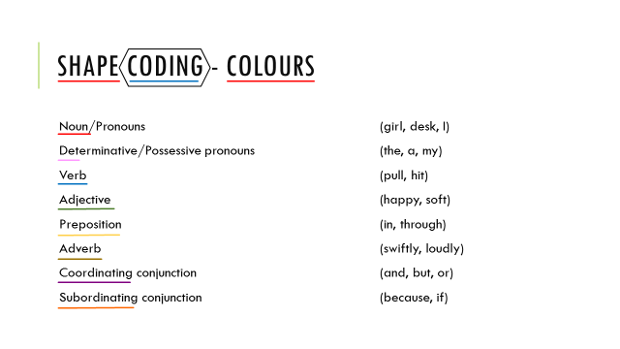
Underpinning Psychology:
Assumption that children with speech & language impairment have visual strengths =
- Montessori (circa 1900)
- The Colour Pattern Scheme, Lea 1965, 1970
- Language Through Reading, Conn, 1973;
- Zwitman and Sonderman, 1979;
- Colourful Semantics, Bryan, 1997;
- Spotlights on Language Communication System, Kaldor et al., 1999, 2001;
- Language Through Colour, Gap House School, 2005
None of these teach complex grammatical rules and most have pretty poor/anecdotal evidence bases = Ebbels designing Shape Coding.
Underpinning Evidence Base:
- Based almost entirely on Ebbels on work, or research Ebbels has been involved in
- Often includes Ebbels delivering the intervention to the participants herself
- Often case study
- One randomised control trial with blind assessor. BUT intervention delivered 1-2-1 by speech & language therapist & only 14 in study group.
- Back to case study design in 2013/14. Ebbels still involved in the research.
Summary
Indications suggest that progress can be made using Shape-Coding, and that it can be maintained for varying periods. But does not usually continue after intervention has stopped.
Further research required to explore the relationship between the degree of progress and maintenance and whether it is easier to maintain progress for some targets than for others. (i.e. wh- questions, dative case, passives etc.)
The idea of coding grammar using colour and shape to teach it explicitly is based on the assumption that children with language impairment have visual strengths – it is likely that children with language impairment appear to learn better with visual cues BECAUSE they don’t have the language to learn in an auditory fashion as is more commonly used in our classrooms.
